CSAI Bachelor Program Analysis Proposal

Program details

* Program name: Cognitive Sciences and Artificial Intelligence
* Academic Director: Dr. Emmanuel Keuleers
* Level: Bachelor program
* Total # of courses: approx. 30, electives included

# Aim of this document

This proposal shows how the TSHD Education Innovation team intends to tackle the CSAI Bachelor Program Analysis. It includes definitions, needs analysis, desired outcomes, the proposed framework to guide the analysis, an implementation plan and a timeline.

This proposal is presented to Dr. Emmanuel Keuleers, CSAI Program Director, for input and approval purposes. Approval of this document officially places the CSAI bachelor program in the Exploring Blended Learning Project as pilot #4.

# Definitions

* Blended Learning = learning as a result of a deliberate, integrated combination of online and face-to-face learning activities (EMBED, 2020)
* Blended teaching = designing and facilitating blended learning activities (EMBED, 2020)
* Maturity = the concept of “maturity” relates to the degree of formality and optimisation of the design, evidence-based decision making, documentation and continuous quality improvement which characterise the uptake of Blended Learning practices, or the implementation of blended learning conditions and strategies (EMBED, 2020)

# Needs analysis

CSAI Academic Director Emmanuel Keuleers reached out to Project Manager for Educational Development and Innovation Petra Heck requesting an analysis of the existing blended learning practices within the program.

Emmanuel reported how several blended learning elements were incorporated into multiple courses over the past year and a half. This happened organically, that is without the explicit application of instructional design principles.

Emmanuel is requesting the instructional designer to carry out a systematic inventory of the courses’ blended learning practices, to identify weaknesses, strengths and to build on such strengths.

# Desired outcomes

The aim of this intervention is to

* map blended learning practices, conditions, strategies and policies in a systematic manner
* formulate an actionable and empowering report that
  + identifies what to keep and what to improve (tracks for optimization and change)
  + Identifies the tools to develop existing practices in a deliberate and coherent manner (in turn leading to orientation and predictability for both teachers and students).
* contribute towards the formulation of a program-level vision
* support in the design and development of such optimization and change tracks (such instructional design and development interventions will focus on some courses only)

Through this intervention, individual lecturers further increase their blended learning design expertise and can justify design choices based on good practices.

Furthermore, the CSAI program as a whole shows stronger program coherence, which refers to how different courses in one program align with each other (horizontal alignment), and also how they align with the program itself (vertical alignment).

## Vision on blended learning

An entry point to the current analysis would be to check existing practices against the program’s stakeholders’ (teachers and administrators) shared vision on blended learning.

It appears however that no vision has already been formulated for the CSAI bachelor program in terms of how education is delivered / the students' learning experience (e.g., the program is blended, courses are designed based on a student-centred approach, students' learning is supported by regular self-assessment opportunities, classes are interactive etc.). What is known so far is that the CSAI program aims to provide its stakeholders (teachers, administrators, students) with a coherent offer that is supported by deliberate choices. This, in turns, leads to orientation and predictability, for both teachers and students.

# Framework

The current analysis is an evidence-based intervention that mainly draws input from the [European Maturity model for Blended Education](https://embed.eadtu.eu/download/2517/EMBED%20implementation%20guidelines.pdf?inline=1) (EMBED 2017-2020)

This model is a framework which can be used to tackle any conceptual or implementation issues regarding blended learning, teaching and education (W.F. van Valkenburg et al., 2020)

The model consists of three levels: course level, program level, and institution level. The current analysis will only focus on the former two levels. Each level has multiple dimensions, which together should give a comprehensive overview of the field of blended learning and education (W.F. van Valkenburg et al., 2020).

Such dimensions, which are further illustrated below, will be used during the document analysis as criteria to benchmark the courses, and the whole program, against. It is worth mentioning that this analysis focuses on instruction and that by no means can serve as a curriculum analysis.

## Course-level dimensions

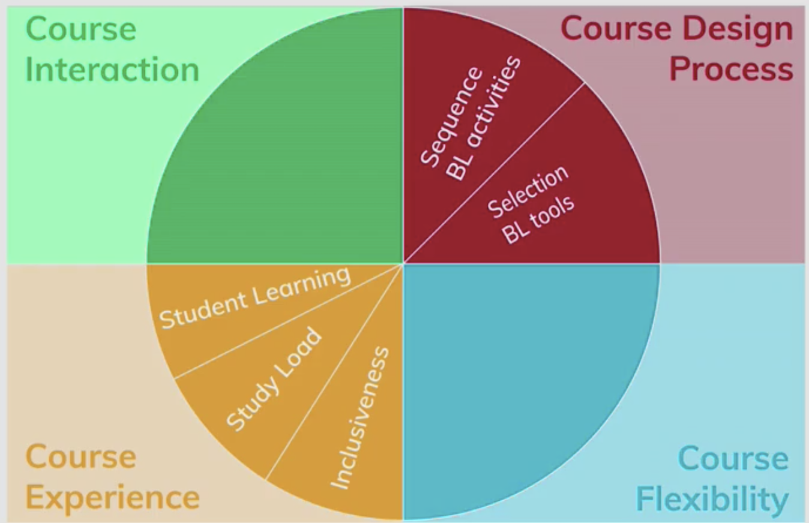

The course level consists of the following four dimensions and corresponding subdimensions:

* Course design process
* **Selection of blended learning activities and their sequence** (f2f and online)
* **Selection of blended learning tools** (for fun/due to availability/to deliberately support the learning activity)

Course flexibility. Deliberately designed **place and time independent learning**, based on students’ preferences and needs: selection of learning activities/resources, mode of delivery (online/face-to-face/hybrid), pace (instructor-paced/self-paced)

* Course interaction: Learner-content, learner-educator, learner-learner
* Course experience
  + **Student learning:** the extent to which the course facilitates students’ self-regulated learning (orienting and planning, monitoring, adjusting and evaluating, self-study/self-assessment).
  + **Study load**: how the intended study load corresponds with the actual study load (online/face-to-face learning activities/exam preparation)
  + **Inclusiveness**: the extent to which a course takes the diverse needs and backgrounds of all students into consideration. Especially with the online part of a blended course this can be challenging (social belonging and identity).

## Input by Emmanuel (practices already in place in the program)

* Lectures are being recorded. They could be used to flip the classroom (falls under selection and sequencing of blended learning activities)
* Canvas use: we exhaust its functionality by using it as an organizational tool for blended learning, but there could be other tools we could use for this organization (falls under selection of BL tools)
* Teaching activities (falls under selection and sequencing of blended learning activities)
* Hybrid teaching and learning (falls under course flexibility)
* Fully online and fully on campus group works (falls under course flexibility)
* Self-assessment, self-study (falls under student learning)

## Program-level dimensions and subdimensions

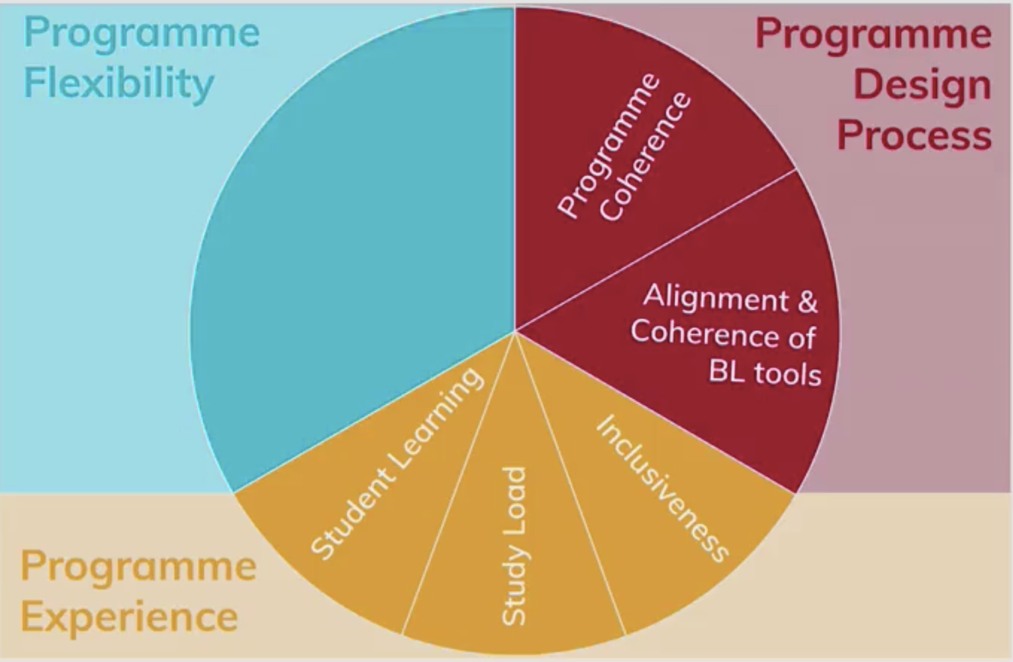

The programme level consists of the following three dimensions and corresponding subdimensions:

* Programme design process.
* **Programme coherence**: how different courses in one programme align with each other (horizontal alignment), and how they align with the programme itself (vertical alignment) based on a shared vision on blended learning and a design method or principles. Such vision and design choices, in turn, shape students’ learning experience.
* **Alignment and coherence of blended learning tools**. The alignment and coherence of the tools used in a programme are based on learning activities in courses and are coordinated by the educators in the program.
* Programme flexibility. To what extent does a programme allow learners to select mode of delivery (online/face-to-face/hybrid activities) and pace (educator-paced/self-paced).
* Programme experience. The extent to which a programme enhances students’ learning and eliminates any obstacles that stand in the way of learning.
* **Student learning**, the extent to which a blended programme features facilitate students’ self-regulated learning (students can plan their programme, know their progress in the programme, and are able to adjust their learning).
* **Study load**, the match between the intended and achieved study load. It also includes the distribution of peak loads between courses.
* **Inclusiveness**. Inclusiveness is aligned in all courses of a programme. Students feel valued, safe, and have a sense of belonging.

# Six-step implementation plan:

Course level

1. Carry out a document analysis by manually analyzing blended learning educational practices across each course (via Canvas). This results in an inventory obtained by systematically checking each course against previously identified blended learning dimensions (see above mentioned EMBED model on course level)
2. Meet teachers with follow up questions, if needed (to be contacted via Team)

(Get support from student/teacher assistant?)

Program level

1. Based on the outcome of the document analysis (inventory), the program is assessed against previously identified blended learning dimensions (see above mentioned EMBED model on program level)
2. A report, including an advice, originates from the previous step

Course level

1. By focusing on a very small number of courses, extrapolate and share with teachers workable recommendations with regard to the application of BL strategies, and quality education in general.
2. Meet such teachers to agree on implementation plan: provide hands-on support to the teachers (on an individual and/or group level, good examples, lists of references, class observation) who wish to act upon such recommendations (redesign activity)

# Timeline

Batch1: semester 1 courses. The document analysis starts as soon as the proposal is approved (mid-December 2021/January 2022).

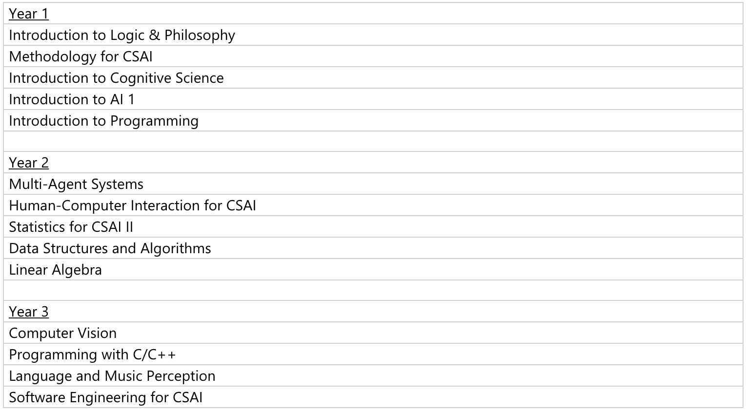

Batch 2: semester 2 courses. The document analysis starts as soon as batch 1 is complete.

# Students’ perspective

How do students react to blended learning practices? Do they participate? Do they appreciate?

# Evaluation

Later on, of the focused interventions...

# Resources

Van Valkenburg, W. F., Dijkstra, W. P., De los Arcos, B., Goeman, K., Van Rompaey, V., & Poelmans, S. (2020, May). European Maturity Model for Blended Education. EADTU. https://embed.eadtu.eu/download/2470/European%20Maturity%20Model%20for%20Blended%20E ducation.pdf?inline=1